**Assignment 10**

**Objective** – Power BI Desktop, Cloud Service and End to EndWorkflow

**Use Case** – Information about Films

**Source** – List of Films, ComfortBreaks

**Analytics** – To find average number of breaks for a film

**Report/Dashboard** – Film Insights

Load Data

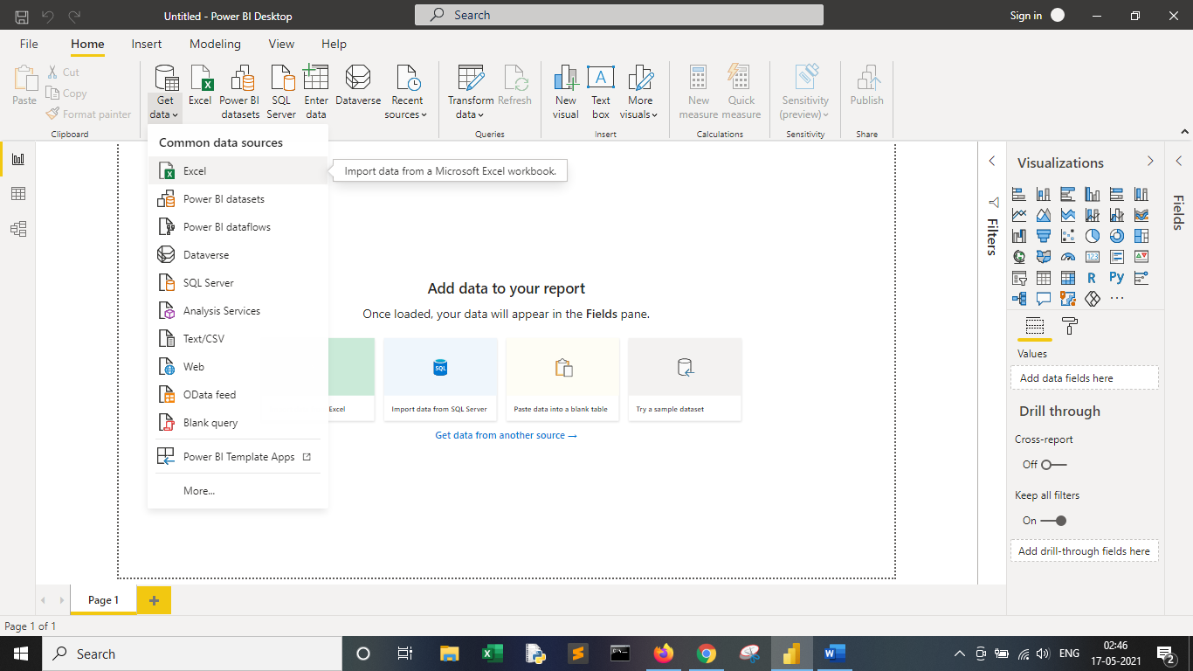

**It contains a table giving how many times the author would need to pop out for a comfort break during each film's screening:**

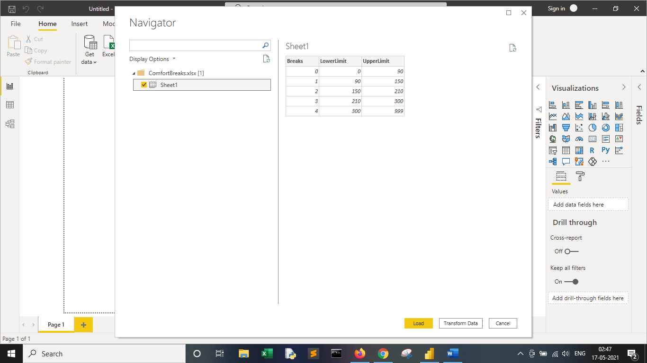

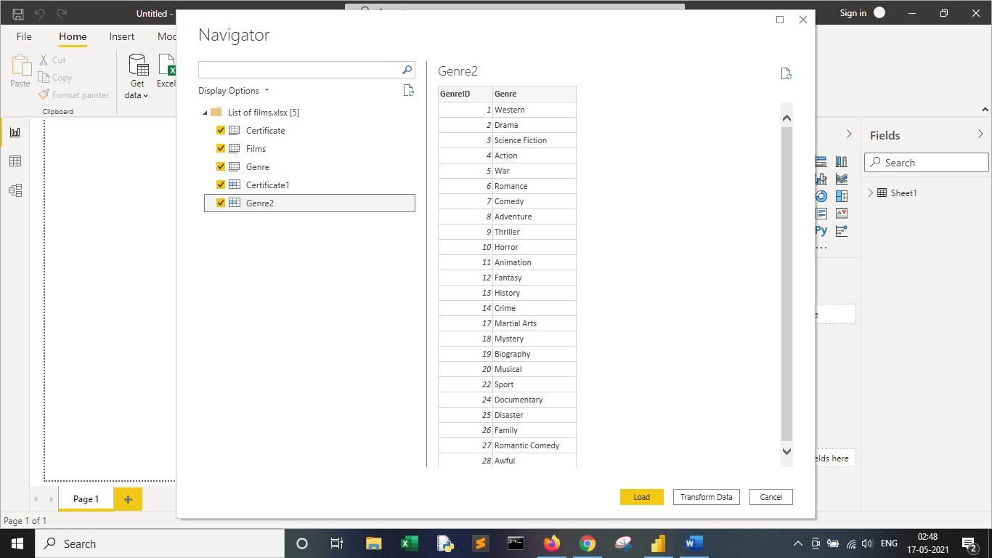

**In the Films table create a calculated column called NumberBreaks which shows for each film the number of breaks needed.**

NumberBreaks = CALCULATE(VALUES(Sheet1[Breaks]),Sheet1[LowerLimit]<=EARLIER(Films[RunTimeMinutes]),Sheet1[UpperLimit]>EARLIER(Films[RunTimeMinutes]))

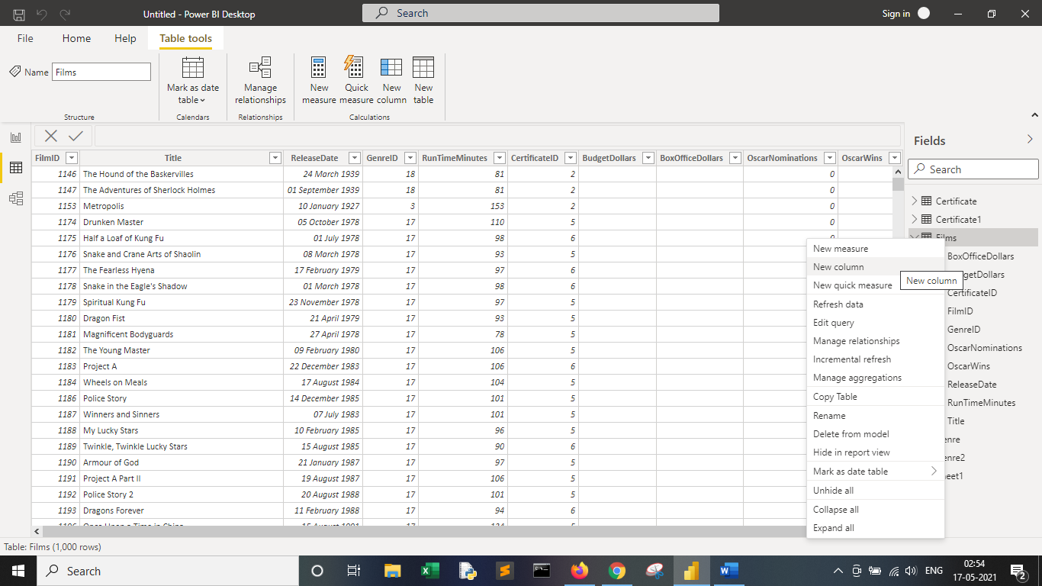

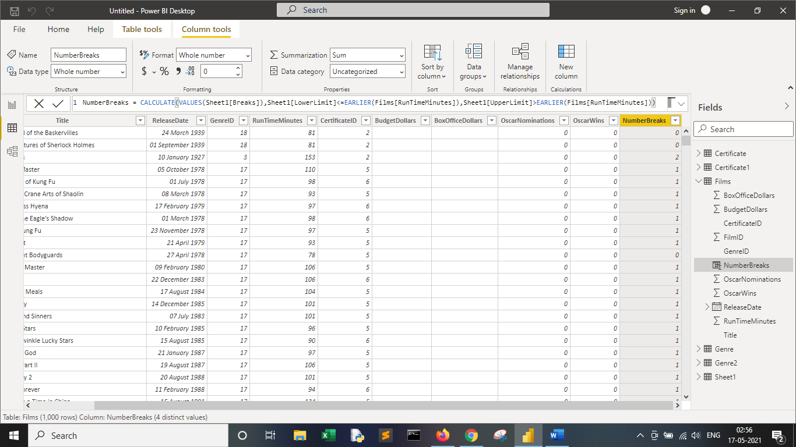

**Try creating a second calculated column to do the same thing, but this time using the method you didn't use the first time.**

Number Breaks 2= SWITCH(TRUE(),Films[RunTimeMinutes]<90,0,Films[RunTimeMinutes]<150,1,Films[RunTimeMinutes]<210,2,Films[RunTimeMinutes]<300,3,4)

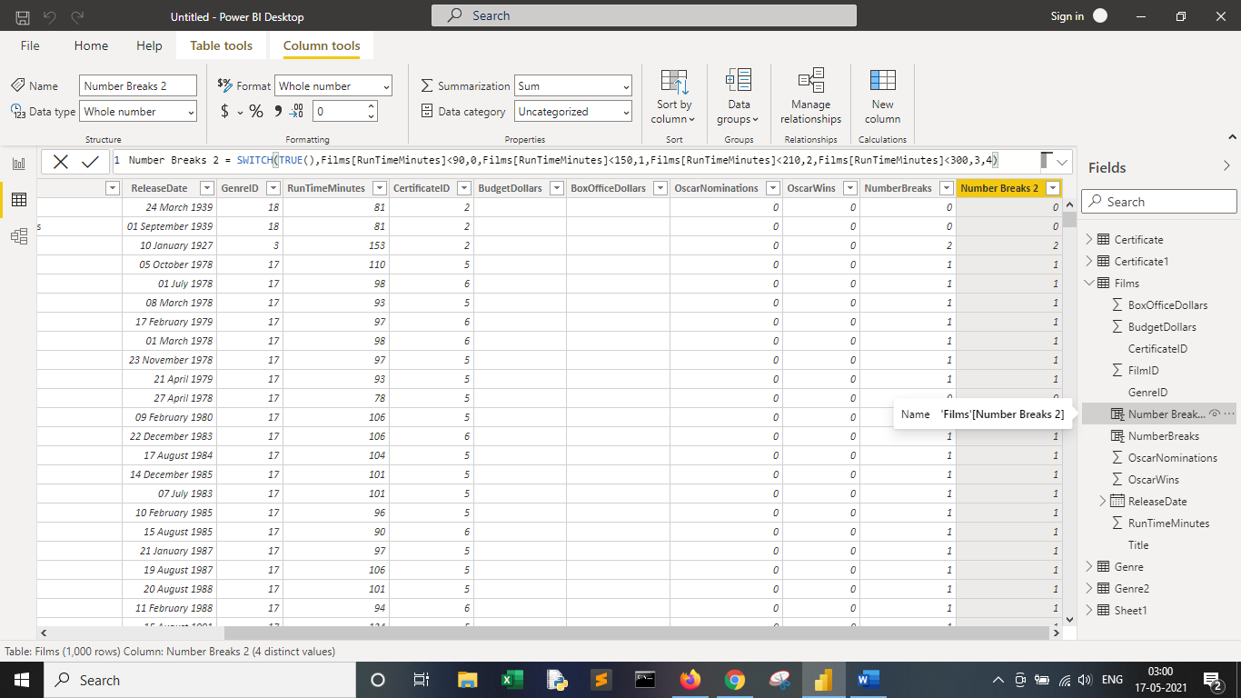

**When you've finished, you should be able to create the following matrix:**

